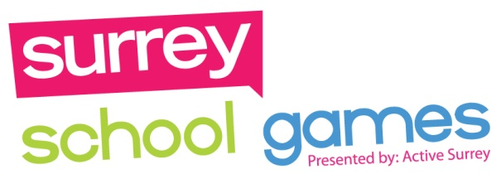

CODE OF CONDUCT

The Dorking School Sport Partnership hopes that everyone has an enjoyable and positive experience.
As teams, volunteers parents and spectators it is expected that you will abide by your own school rules throughout the event.
We also ask that everyone involved commits to following the Values of the Dorking Schools Sports Partnership and Surrey School Games:

Determination
Children are expected to motivate themselves and keep a positive attitude.
Parents, spectators and children are expected to applaud all good play by all teams
Honesty
Children are expected to play by the rules and always behave fairly and honestly
Children are expected to treat others how they would like to be treated.
Passion
Children are expected to play with commitment and strive to achieve their best.
Children are expected to try to be an inspiration to others
Respect
Parents, children and spectators are expected to show respect to officials, event staff, volunteers, competitors & the venue
Parents, spectators and children are expected not to question match officials decisions.
Parents, spectators and children are expected not to make negative comments to/about a child or teammate
Self Belief
Children are expected to have confidence in their own abilities.
Children are expected to push themselves to achieve new personal bests.
Team Work
Children are expected to work as a team, supporting and encouraging each other.
Parents, spectators and children are expected to praise others efforts whether they win or lose.

We encourage competitors, organisers, supporters and volunteers to remember these values and embody them where possible.

