Drawing Challenges for Children
A suggestion on the page below if your child enjoys art. 52 drawing challenges!
Your child may not know that “Anthropomorphic” (no. 31) means giving something human characteristics for example cars and trains in animated cartoons!
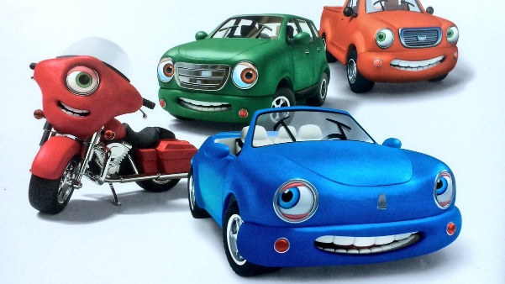

Also if, like me, you have never heard of “Zentangle” doodles (no. 9), wonder no more! I will share my learning…
“Zentangle is an easy-to-learn, relaxing, and fun way to create beautiful images by drawing structured patterns called tangles. You create tangles with combinations of dots, lines, simple curves, S-curves and orbs.”
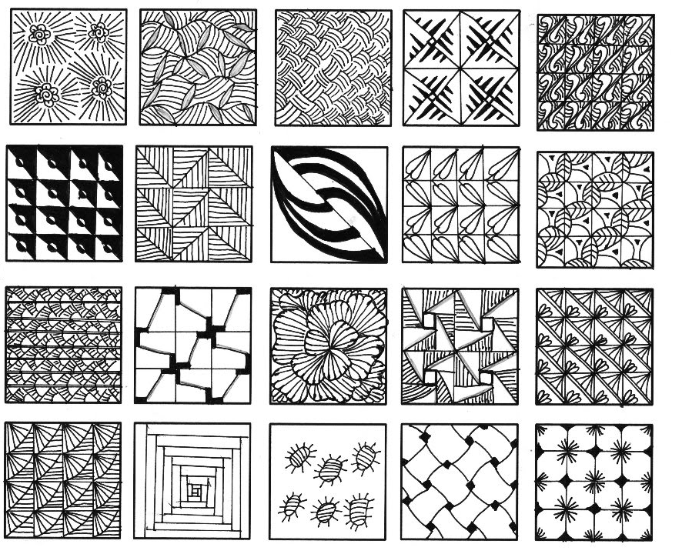

There are some short video demonstrations on Youtube too; it looks quite relaxing!
https://www.youtube.com/watch?v=ycsONJVXcac
https://www.youtube.com/watch?v=gBsW_wpFBxc

